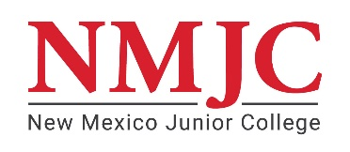
Student’s Name: _________________________________A#:__________________ Date of Birth:______________
RELIGIOUS EXEMPTION CERTIFICATION
Instructions: Please complete either the top or bottom section of the form to release information to New Mexico Junior College (NMJC) regarding your request for an exemption for you from receiving the COVID-19 vaccine due to your religious beliefs.
TO BE COMPLETED BY YOUR RELIGIOUS AUTHORITY:
I, _______________________________________ [Name of Religious Affiliation Authority] certify that the above-named student is an active member/participant in my congregation/organization and that the vaccination is against his/her religious beliefs:
Religious Authority Signature: _____________________________________ Date ___________________
Name of Religious Organization: ____________________________________________________________
Address of Religious Organization: __________________________________________________________
OR
I have provided this notarized certificate certifying that I receiving the COVID-19 vaccine is against my sincerely held religious beliefs.
Student Signature: ______________________________________________ Date ___________________
Parent/Legal Guardian Signature*: _________________________________ Date ___________________
*Needed only if student is under 18 years of age.
Notary
Subscribed and sworn before me this _________ day of ___________________ , 20 _______________ ,
_______________________________________ My Commission expires: ________________________
Notary's Signature

Notary Seal
Return Exemption Form to: spatterson@nmjc.edu or Dean of Students, 1 Thunderbird Circle, Hobbs, NM, 88240
NMJC Use Only: Approved Denied
Authorized Signature ________________________________________ Date _____________________

