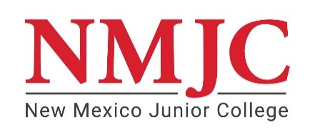
Student’s Name:_______________________ A#:__________________ Date of Birth:_______________
MEDICAL EXEMPTION CERTIFICATION
Instructions: Please complete this form to release information regarding your request for an accommodation exempting you from receiving the COVID-19 vaccine due to your health condition.
I have provided this certificate, signed and dated by my licensed health care provider, certifying that receiving the COVID-19 vaccine is contraindicated for me due to applicable CDC contraindications and/or my medical condition.

Student Signature: ______________________________________________ Date ___________________
Parent/Legal Guardian Signature*: _________________________________ Date ___________________
*Needed only if student is under 18 years of age.

--------------------------------------------------------------------------------------------------------------------------------------------------------
THIS SECTION TO BE COMPLETED BY A LICENCED MEDICAL PROVIDER:
I, ____________________________________________________ [Printed name of licensed MD, DO, PA, NP] certify that the above-named student is under my medical care and has a medical condition that contraindicates his/her vaccination with the COVID-19 Vaccine at this time.
Health Care Provider Signature: _________________________________________ Date: ____________________
Health Care Provider Contact Info: _________________________________________________________Physician
__________________________________________________ Address
___________________ State _____________________ Zip Code
__________________________________________________ Phone #

Return Exemption Form to: spatterson@nmjc.edu or Dean of Students, 1 Thunderbird Circle, Hobbs, NM, 88240

NMJC Use Only: ______ Approved ______ Denied

Authorized Signature ________________________________________ Date ______________________

