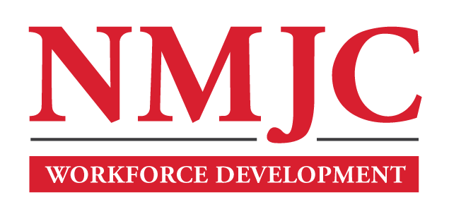
Pharmacy Technician Program – NMJC – Workforce Development
Tuition - $1,400; Total Hours – 50 classroom + 80 clinical externship
Location 5317 N. Lovington Hwy, Hobbs, NM 88240
Tuesday September 26 6:00pm - 9:30pm
Thursday September 28 6:00pm - 9:30pm

Tuesday October 3 6:00pm - 9:30pm
Thursday October 5 6:00pm - 9:30pm

Tuesday October 10 6:00pm - 9:30pm
Thursday October 12 6:00pm - 9:30pm

Tuesday October 17 6:00pm - 9:30pm
Thursday October 19 6:00pm - 9:30pm

Tuesday October 24 6:00pm - 9:30pm
Thursday October 26 6:00pm - 9:30pm

Tuesday October 31 6:00pm - 9:30pm
Thursday November 2 6:00pm - 9:30pm

Tuesday November 7 6:00pm - 9:30pm
Thursday November 9 6:00pm - 9:30pm

Tuesday November 14 6:00pm - 9:30pm

