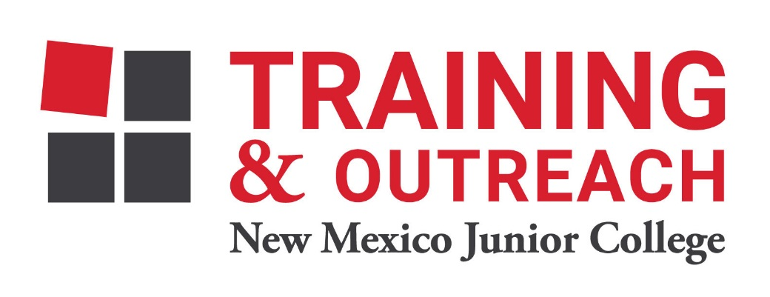
Pharmacy Technician Program – NMJC – Training & Outreach
Tuition - $1,400; Total Hours – 50 classroom + 80 clinical externship
Location 5317 N. Lovington Hwy, Hobbs, NM 88240
Tuesday September 21 6:00pm - 9:30pm
Thursday September 23 6:00pm - 9:30pm

Tuesday September 28 6:00pm - 9:30pm
Thursday September 30 6:00pm - 9:30pm

Tuesday October 5 6:00pm - 9:30pm
Thursday October 7 6:00pm - 9:30pm

Tuesday October 12 6:00pm - 9:30pm
Thursday October 14 6:00pm - 9:30pm

Tuesday October 19 6:00pm - 9:30pm
Thursday October 21 6:00pm - 9:30pm

Tuesday October 26 6:00pm - 9:30pm
Thursday October 28 6:00pm - 9:30pm

Tuesday November 2 6:00pm - 9:30pm
Thursday November 4 6:00pm - 9:30pm

Tuesday November 9 6:00pm - 9:30pm

