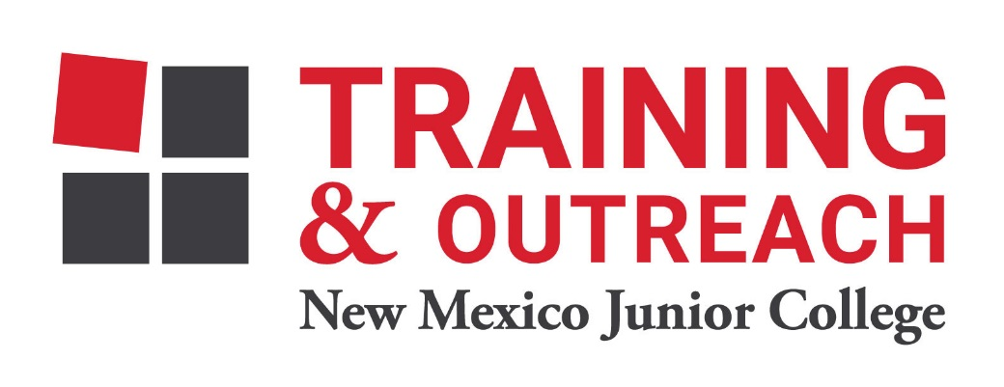
Dental Assisting Program – NMJC – Training & Outreach
Tuition - $1,200; Total Hours – 60
Location 5317 N. Lovington Hwy, Hobbs, NM 88240
Monday May 23 6:00pm - 9:30pm
Wednesday May 25 6:00pm - 9:30pm

NO CLASS May 30 NO CLASS
Wednesday June 1 6:00pm - 9:30pm

Monday June 6 6:00pm - 9:30pm
Wednesday June 8 6:00pm - 9:30pm

Monday June 13 6:00pm - 9:30pm
Wednesday June 15 6:00pm - 9:30pm

Monday June 20 6:00pm - 9:30pm
Wednesday June 22 6:00pm - 9:30pm

Monday June 27 6:00pm - 9:30pm
Wednesday June 29 6:00pm - 9:30pm

NO CLASS July 4 NO CLASS
Wednesday July 6 6:00pm - 9:30pm

Monday July 11 6:00pm - 9:30pm
Wednesday July 13 6:00pm - 9:30pm

Monday July 18 6:00pm - 9:30pm
Wednesday July 20 6:00pm - 9:30pm

Monday July 25 6:00pm - 9:30pm

