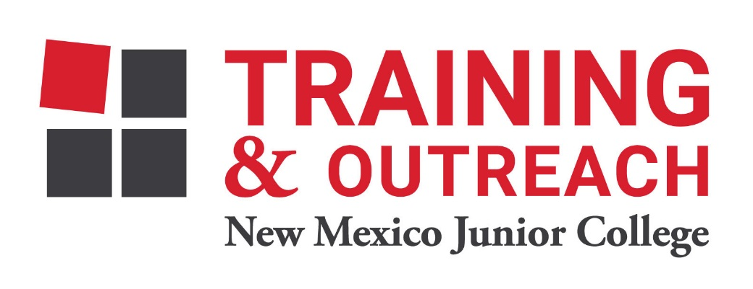
Dental Assisting Program – NMJC – Training & Outreach
Tuition - $1,200; Total Hours – 60
Location 5317 N. Lovington Hwy, Hobbs, NM 88240
Monday October 11 6:00pm - 9:30pm
Wednesday October 13 6:00pm - 9:30pm

Monday October 18 6:00pm - 9:30pm
Wednesday October 20 6:00pm - 9:30pm

Monday October 25 6:00pm - 9:30pm
Wednesday October 27 6:00pm - 9:30pm

Monday November 1 6:00pm - 9:30pm
Wednesday November 3 6:00pm - 9:30pm

Monday November 8 6:00pm - 9:30pm
Wednesday November 10 6:00pm - 9:30pm

Monday November 15 6:00pm - 9:30pm
Wednesday November 17 6:00pm - 9:30pm

NO CLASS Nov 22 - 26 NO CLASS

Monday November 29 6:00pm - 9:30pm
Wednesday December 2 6:00pm - 9:30pm

Monday December 6 6:00pm - 9:30pm
Wednesday December 8 6:00pm - 9:30pm

Monday December 13 6:00pm - 9:30pm

