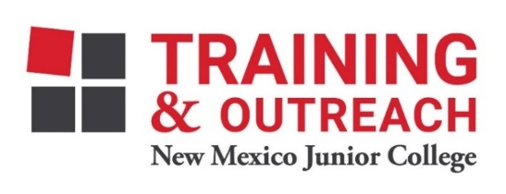
Clinical Medical Assistant Program – NMJC – Training & Outreach
Tuition - $2,600; Total Hours – 140 classroom + 160 hours clinical time
Location: 5317 N. Lovington Hwy, Hobbs, NM 88240
Tuesday August 22 6:00pm - 9:30pm
Thursday August 24 6:00pm - 9:30pm

Tuesday August 29 6:00pm - 9:30pm
Thursday August 31 6:00pm - 9:30pm

Tuesday September 5 6:00pm - 9:30pm
Thursday September 7 6:00pm - 9:30pm
Saturday September 9 9:00am - 4:30pm

Tuesday September 12 6:00pm - 9:30pm
Thursday September 14 6:00pm - 9:30pm

Tuesday September 19 6:00pm - 9:30pm
Thursday September 21 6:00pm - 9:30pm
Saturday September 23 9:00am - 4:30pm

Tuesday September 26 6:00pm - 9:30pm
Thursday September 28 6:00pm - 9:30pm

Tuesday October 3 6:00pm - 9:30pm
Thursday October 5 6:00pm - 9:30pm
Saturday October 7 9:00am - 4:30pm

Tuesday October 10 6:00pm - 9:30pm
Thursday October 12 6:00pm - 9:30pm

Tuesday October 17 6:00pm - 9:30pm
Thursday October 19 6:00pm - 9:30pm
Saturday October 21 9:00am - 4:30pm

Tuesday October 24 6:00pm - 9:30pm
Thursday October 26 6:00pm - 9:30pm

Tuesday October 31 6:00pm - 9:30pm
Thursday November 2 6:00pm - 9:30pm
Saturday November 4 9:00am - 4:30pm

Tuesday November 7 6:00pm - 9:30pm
Thursday November 9 6:00pm - 9:30pm

Tuesday November 14 6:00pm - 9:30pm
Thursday November 16 6:00pm - 9:30pm
Saturday November 18 9:00am - 4:30pm

NO CLASS November 21 NO CLASS
NO CLASS November 23 NO CLASS

Tuesday November 28 6:00pm - 9:30pm
Thursday November 30 6:00pm - 9:30pm

