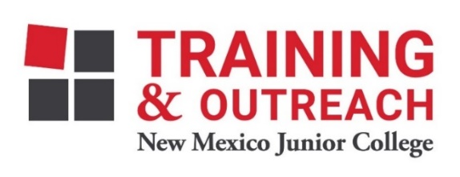
Clinical Medical Assistant Program – NMJC – Training & Outreach
Tuition - $2,600; Total Hours – 140 classroom + 160 hours clinical time
Location: 5317 N. Lovington Hwy, Hobbs, NM 88240
Monday March 7 6:00pm - 9:30pm
Wednesday March 9 6:00pm - 9:30pm

Monday March 14 6:00pm - 9:30pm
Wednesday March 16 6:00pm - 9:30pm
Saturday March 19 9:00am - 4:30pm

NO CLASS March 21-25 NO CLASS

Monday March 28 6:00pm - 9:30pm
Wednesday March 30 6:00pm - 9:30pm
Saturday April 2 9:00am - 4:30pm

Monday April 4 6:00pm - 9:30pm
Wednesday April 6 6:00pm - 9:30pm

Monday April 11 6:00pm - 9:30pm
Wednesday April 13 6:00pm - 9:30pm

Monday April 18 6:00pm - 9:30pm
Wednesday April 20 6:00pm - 9:30pm
Saturday April 23 9:00am - 4:30pm

Monday April 25 6:00pm - 9:30pm
Wednesday April 27 6:00pm - 9:30pm

Monday May 2 6:00pm - 9:30pm
Wednesday May 4 6:00pm - 9:30pm
Saturday May 7 9:00am - 4:30pm

Monday May 9 6:00pm - 9:30pm
Wednesday May 11 6:00pm - 9:30pm

Monday May 16 6:00pm - 9:30pm
Wednesday May 18 6:00pm - 9:30pm
Saturday May 21 9:00am - 4:30pm

NO CLASS May 23 NO CLASS
NO CLASS May 25 NO CLASS

NO CLASS May 30 NO CLASS
Wednesday June 1 6:00pm - 9:30pm
Saturday June 4 9:00am - 4:30pm

Monday June 6 6:00pm - 9:30pm
Wednesday June 8 6:00pm - 9:30pm

Monday June 13 6:00pm - 9:30pm
Wednesday June 15 6:00pm - 9:30pm

Monday June 20 6:00pm - 9:30pm
Wednesday June 22 6:00pm - 9:30pm

Monday June 27 6:00pm - 9:30pm

