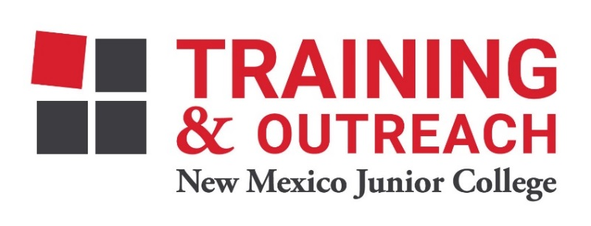

Clinical Medical Assistant Program – NMJC – Training & Outreach
Tuition - $2,600; Total Hours – 140 classroom + 160 hours clinical time
Location: 5317 N. Lovington Hwy, Hobbs, NM 88240
Tuesday January 19 6:00pm - 9:30pm
Thursday January 21 6:00pm - 9:30pm

Tuesday January 26 6:00pm - 9:30pm
Thursday January 28 6:00pm - 9:30pm
Saturday January 30 9:00am - 4:30pm

Tuesday February 2 6:00pm - 9:30pm
Thursday February 4 6:00pm - 9:30pm

Tuesday February 9 6:00pm - 9:30pm
Thursday February 11 6:00pm - 9:30pm
Saturday February 13 9:00am - 4:30pm

Tuesday February 16 6:00pm - 9:30pm
Thursday February 18 6:00pm - 9:30pm

Tuesday February 23 6:00pm - 9:30pm
Thursday February 25 6:00pm - 9:30pm
Saturday February 27 9:00am - 4:30pm

Tuesday March 2 6:00pm - 9:30pm
Thursday March 4 6:00pm - 9:30pm

Tuesday March 9 6:00pm - 9:30pm
Thursday March 11 6:00pm - 9:30pm
Saturday March 13 9:00am - 4:30pm

Tuesday March 16 6:00pm - 9:30pm
Thursday March 18 6:00pm - 9:30pm

NO CLASS March 23-25 NO CLASS

Tuesday March 30 6:00pm - 9:30pm
Thursday April 1 6:00pm - 9:30pm

Tuesday April 6 6:00pm - 9:30pm
Thursday April 8 6:00pm - 9:30pm
Saturday April 10 9:00am - 4:30pm

Tuesday April 13 6:00pm - 9:30pm
Thursday April 15 6:00pm - 9:30pm
Saturday April 17 9:00am - 4:30pm

Tuesday April 20 6:00pm - 9:30pm
Thursday April 22 6:00pm - 9:30pm

Tuesday April 27 6:00pm - 9:30pm
Thursday April 29 6:00pm - 9:30pm

