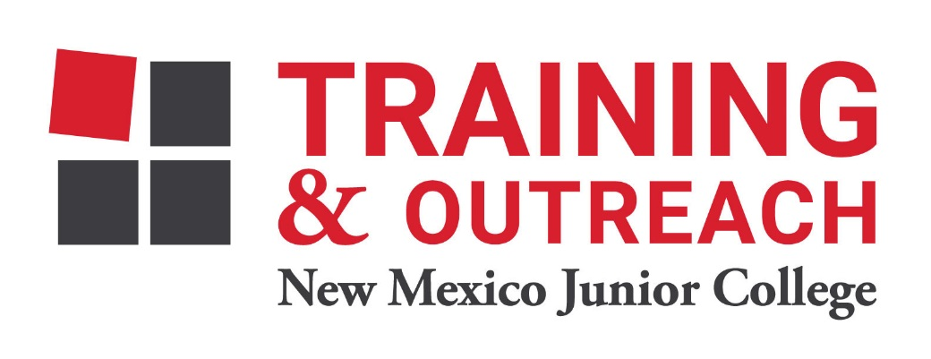
Pharmacy Technician Program – NMJC – Training & Outreach
Tuition - $1,400; Total Hours – 50 classroom + 80 clinical externship
Location 5317 N. Lovington Hwy, Hobbs, NM 88240

Tuesday June 6 6:00pm - 9:30pm
Thursday June 8 6:00pm - 9:30pm

Tuesday June 13 6:00pm - 9:30pm
Thursday June 15 6:00pm - 9:30pm

Tuesday June 20 6:00pm - 9:30pm
Thursday June 22 6:00pm - 9:30pm

Tuesday June 27 6:00pm - 9:30pm
Thursday June 29 6:00pm - 9:30pm

Tuesday July 4 NO CLASS
Thursday July 6 6:00pm - 9:30pm

Tuesday July 11 6:00pm - 9:30pm
Thursday July 13 6:00pm - 9:30pm

Tuesday July 18 6:00pm - 9:30pm
Thursday July 20 6:00pm - 9:30pm

Tuesday July 25 6:00pm - 9:30pm
Thursday July 27 6:00pm - 9:30pm

