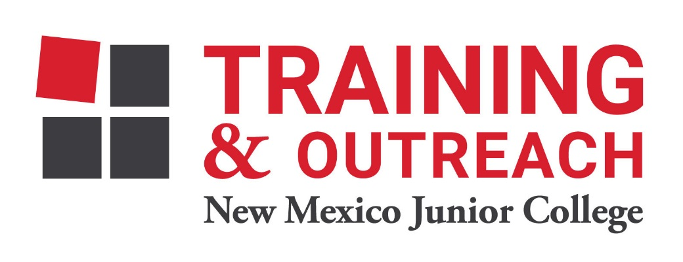
Pharmacy Technician Program – NMJC – Training & Outreach
Tuition - $1,400; Total Hours – 50 classroom + 80 clinical externship
Location 5317 N. Lovington Hwy, Hobbs, NM 88240
Tuesday September 27 6:00pm - 9:30pm
Thursday September 29 6:00pm - 9:30pm

Tuesday October 4 6:00pm - 9:30pm
Thursday October 6 6:00pm - 9:30pm

Tuesday October 11 6:00pm - 9:30pm
Thursday October 13 6:00pm - 9:30pm

Tuesday October 18 6:00pm - 9:30pm
Thursday October 20 6:00pm - 9:30pm

Tuesday October 25 6:00pm - 9:30pm
Thursday October 27 6:00pm - 9:30pm

Tuesday November 1 6:00pm - 9:30pm
Thursday November 3 6:00pm - 9:30pm

Tuesday November 8 6:00pm - 9:30pm
Thursday November 10 6:00pm - 9:30pm

Tuesday November 15 6:00pm - 9:30pm

