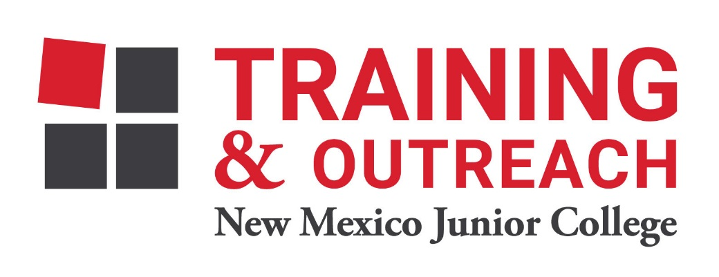
Pharmacy Technician Program – NMJC – Training & Outreach
Tuition - $1,400; Total Hours – 50 classroom + 80 clinical externship
Location 5317 N. Lovington Hwy, Hobbs, NM 88240
Tuesday February 7 6:00pm - 9:30pm
Thursday February 9 6:00pm - 9:30pm

Tuesday February 14 6:00pm - 9:30pm
Thursday February 16 6:00pm - 9:30pm

Tuesday February 21 6:00pm - 9:30pm
Thursday February 23 6:00pm - 9:30pm

Tuesday February 28 6:00pm - 9:30pm
Thursday March 2 6:00pm - 9:30pm

Tuesday March 7 6:00pm - 9:30pm
Thursday March 9 6:00pm - 9:30pm

NO CLASS March 14 NO CLASS
NO CLASS March 16 NO CLASS

Tuesday March 21 6:00pm - 9:30pm
Thursday March 23 6:00pm - 9:30pm

Tuesday March 28 6:00pm - 9:30pm
Thursday March 30 6:00pm - 9:30pm

Tuesday April 4 6:00pm - 9:30pm

