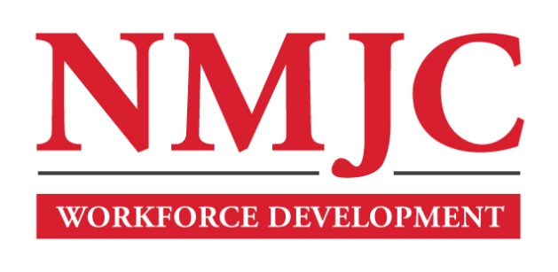
Pharmacy Technician Program – NMJC – Training & Outreach
Tuition - $1,400; Total Hours – 50 classroom + 80 clinical externship
Location 5317 N. Lovington Hwy, Hobbs, NM 88240
Tuesday February 6 6:00pm - 9:30pm
Thursday February 8 6:00pm - 9:30pm

Tuesday February 13 6:00pm - 9:30pm
Thursday February 15 6:00pm - 9:30pm

Tuesday February 20 6:00pm - 9:30pm
Thursday February 22 6:00pm - 9:30pm

Tuesday February 27 6:00pm - 9:30pm
Thursday February 29 6:00pm - 9:30pm

Tuesday March 5 6:00pm - 9:30pm
Thursday March 7 6:00pm - 9:30pm

Tuesday March 12 6:00pm - 9:30pm
Thursday March 14 6:00pm - 9:30pm

NO CLASS March 19 NO CLASS
NO CLASS March 21 NO CLASS

Tuesday March 26 6:00pm - 9:30pm
Thursday March 28 6:00pm - 9:30pm

Tuesday April 2 6:00pm - 9:30pm

