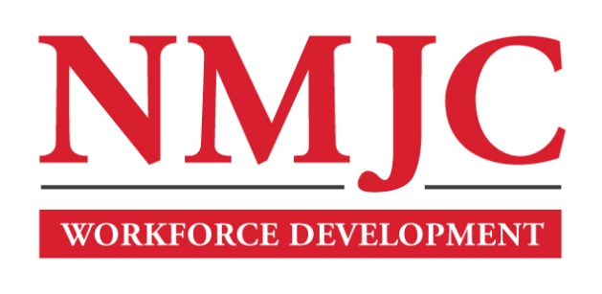
Dental Assisting Program – NMJC – Training & Outreach
Tuition - $1,200; Total Hours – 60
Location 5317 N. Lovington Hwy, Hobbs, NM 88240
Monday April 1 6:00pm - 9:30pm
Wednesday April 3 6:00pm - 9:30pm

Monday April 8 6:00pm - 9:30pm
Wednesday April 10 6:00pm - 9:30pm

Monday April 15 6:00pm - 9:30pm
Wednesday April 17 6:00pm - 9:30pm

Monday April 22 6:00pm - 9:30pm
Wednesday April 24 6:00pm - 9:30pm

Monday April 29 6:00pm - 9:30pm
Wednesday May 1 6:00pm - 9:30pm

Monday May 6 6:00pm - 9:30pm
Wednesday May 8 6:00pm - 9:30pm

Monday May 13 6:00pm - 9:30pm
Wednesday May 15 6:00pm - 9:30pm

NO CLASS May 20 NO CLASS
NO CLASS May 22 NO CLASS

NO CLASS May 27 NO CLASS
Wednesday May 29 6:00pm - 9:30pm

Monday June 3 6:00pm - 9:30pm
Wednesday June 5 6:00pm - 9:30pm

