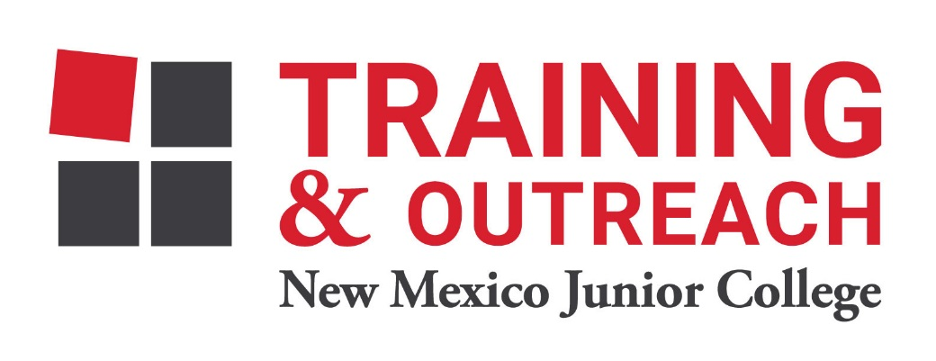
Dental Assisting Program – NMJC – Training & Outreach
Tuition - $1,200; Total Hours – 60
Location 5317 N. Lovington Hwy, Hobbs, NM 88240

Monday February 6 6:00pm - 9:30pm
Wednesday February 8 6:00pm - 9:30pm

Monday February 13 6:00pm - 9:30pm
Wednesday February 15 6:00pm - 9:30pm

NO CLASS February 20 NO CLASS
Wednesday February 22 6:00pm - 9:30pm

Monday February 27 6:00pm - 9:30pm
Wednesday March 1 6:00pm - 9:30pm

Monday March 6 6:00pm - 9:30pm
Wednesday March 8 6:00pm - 9:30pm

NO CLASS March 13 NO CLASS
NO CLASS March 15 NO CLASS

Monday March 20 6:00pm - 9:30pm
Wednesday March 22 6:00pm - 9:30pm

Monday March 27 6:00pm - 9:30pm
Wednesday March 29 6:00pm - 9:30pm

Monday April 3 6:00pm - 9:30pm
Wednesday April 5 6:00pm - 9:30pm

Monday April 10 6:00pm - 9:30pm
Wednesday April 12 6:00pm - 9:30pm

