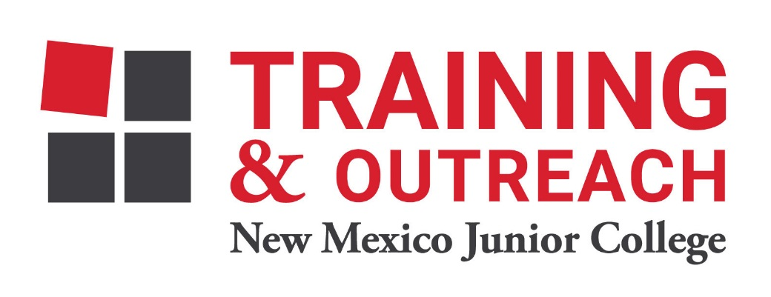
Dental Assisting Program – NMJC – Training & Outreach
Tuition - $1,200; Total Hours – 60
Location 5317 N. Lovington Hwy, Hobbs, NM 88240
Monday October 3 6:00pm - 9:30pm
Wednesday October 5 6:00pm - 9:30pm

Monday October 10 6:00pm - 9:30pm
Wednesday October 12 6:00pm - 9:30pm

Monday October 17 6:00pm - 9:30pm
Wednesday October 19 6:00pm - 9:30pm

Monday October 24 6:00pm - 9:30pm
Wednesday October 26 6:00pm - 9:30pm

Monday October 31 6:00pm - 9:30pm
Wednesday November 2 6:00pm - 9:30pm

Monday November 7 6:00pm - 9:30pm
Wednesday November 9 6:00pm - 9:30pm

Monday November 14 6:00pm - 9:30pm
Wednesday November 16 6:00pm - 9:30pm

NO CLASS Nov 21 - 25 NO CLASS

Monday November 28 6:00pm - 9:30pm
Wednesday November 30 6:00pm - 9:30pm

Monday December 5 6:00pm - 9:30pm

