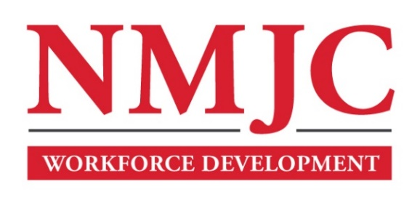
Clinical Medical Assistant Program – NMJC – Training & Outreach
Tuition - $2,700; Total Hours – 140 classroom + 160 hours clinical time
Location: 5317 N. Lovington Hwy, Hobbs, NM 88240

Monday September 16 6:00pm - 9:30pm
Wednesday September 18 6:00pm - 9:30pm

Monday September 23 6:00pm - 9:30pm
Wednesday September 25 6:00pm - 9:30pm

Monday September 30 6:00pm - 9:30pm
Wednesday October 2 6:00pm - 9:30pm
Saturday (WFD) October 5 9:00am - 4:30pm

Monday October 7 6:00pm - 9:30pm
Wednesday October 9 6:00pm - 9:30pm
Saturday October 12 9:00am - 4:30pm

Monday October 14 6:00pm - 9:30pm
Wednesday October 16 6:00pm - 9:30pm

Monday October 21 6:00pm - 9:30pm
Wednesday October 23 6:00pm - 9:30pm
Saturday October 26 9:00am - 4:30pm

Monday October 28 6:00pm - 9:30pm
Wednesday October 30 6:00pm - 9:30pm

Monday November 4 6:00pm - 9:30pm
Wednesday November 6 6:00pm - 9:30pm
Saturday November 9 9:00am - 4:30pm

Monday November 11 6:00pm - 9:30pm
Wednesday November 13 6:00pm - 9:30pm

Monday November 18 6:00pm - 9:30pm
Wednesday November 20 6:00pm - 9:30pm
Saturday November 23 9:00am - 4:30pm

NO CLASS November 25 NO CLASS
NO CLASS November 27 NO CLASS

Monday December 2 6:00pm - 9:30pm
Wednesday December 4 6:00pm - 9:30pm
Saturday December 7 9:00am - 4:30pm

Monday December 9 6:00pm - 9:30pm
Wednesday December 11 6:00pm - 9:30pm
Saturday December 14 9:00am - 4:30pm

Tuesday December 16 6:00pm - 9:30pm
Thursday December 18 6:00pm - 9:30pm

