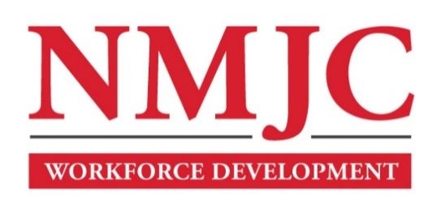
Clinical Medical Assistant Program – NMJC – Training & Outreach
Tuition - $2,600; Total Hours – 140 classroom + 160 hours clinical time
Location: 5317 N. Lovington Hwy, Hobbs, NM 88240
Tuesday May 7 6:00pm - 9:30pm
Thursday May 9 6:00pm - 9:30pm

Tuesday May 14 6:00pm - 9:30pm
Thursday May 16 6:00pm - 9:30pm
Saturday May 18 9:00am - 4:30pm

Tuesday May 21 6:00pm - 9:30pm
Thursday May 23 6:00pm - 9:30pm

Tuesday May 28 6:00pm - 9:30pm
Thursday May 30 6:00pm - 9:30pm
Saturday June 1 9:00am - 4:30pm

Tuesday June 4 6:00pm - 9:30pm
Thursday June 6 6:00pm - 9:30pm

Tuesday June 11 6:00pm - 9:30pm
NO CLASS June 13 NO CLASS

Tuesday June 18 6:00pm - 9:30pm
Thursday June 20 6:00pm - 9:30pm

Tuesday June 25 6:00pm - 9:30pm
Thursday June 27 6:00pm - 9:30pm
Saturday June 29 9:00am - 4:30pm

Tuesday July 2 6:00pm - 9:30pm
Thursday July 4 6:00pm - 9:30pm

Tuesday July 9 6:00pm - 9:30pm
Thursday July 11 6:00pm - 9:30pm
Saturday July 13 9:00am - 4:30pm

Tuesday July 16 6:00pm - 9:30pm
Thursday July 18 6:00pm - 9:30pm

Tuesday July 23 6:00pm - 9:30pm
Thursday July 25 6:00pm - 9:30pm
Saturday July 27 9:00am - 4:30pm

Tuesday July 30 6:00pm - 9:30pm
Thursday August 1 6:00pm - 9:30pm

Tuesday August 6 6:00pm - 9:30pm
Thursday August 8 6:00pm - 9:30pm

Tuesday August 13 6:00pm - 9:30pm
Thursday August 15 6:00pm - 9:30pm

Tuesday August 20 6:00pm - 9:30pm

