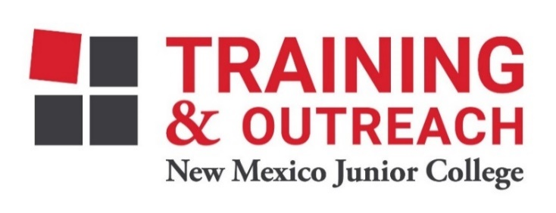
Clinical Medical Assistant Program – NMJC – Training & Outreach
Tuition - $2,600; Total Hours – 140 classroom + 160 hours clinical time
Location: 5317 N. Lovington Hwy, Hobbs, NM 88240
Monday March 20 6:00pm - 9:30pm
Wednesday March 22 6:00pm - 9:30pm

Monday March 27 6:00pm - 9:30pm
Wednesday March 29 6:00pm - 9:30pm
Saturday April 1 9:00am - 4:30pm

Monday April 3 6:00pm - 9:30pm
Wednesday April 5 6:00pm - 9:30pm

Monday April 10 6:00pm - 9:30pm
Wednesday April 12 6:00pm - 9:30pm

Monday April 17 6:00pm - 9:30pm
Wednesday April 19 6:00pm - 9:30pm
Saturday April 22 9:00am - 4:30pm

Monday April 24 6:00pm - 9:30pm
Wednesday April 26 6:00pm - 9:30pm

Monday May 1 6:00pm - 9:30pm
Wednesday May 3 6:00pm - 9:30pm
Saturday May 6 9:00am - 4:30pm

Monday May 8 6:00pm - 9:30pm
Wednesday May 10 6:00pm - 9:30pm

Monday May 15 6:00pm - 9:30pm
Wednesday May 17 6:00pm - 9:30pm
Saturday May 20 9:00am - 4:30pm

Monday May 22 6:00pm - 9:30pm
Wednesday May 24 6:00pm - 9:30pm

NO CLASS May 29 NO CLASS
Wednesday May 31 6:00pm - 9:30pm
Saturday June 3 9:00am - 4:30pm

Monday June 5 6:00pm - 9:30pm
Wednesday June 7 6:00pm - 9:30pm

Monday June 12 6:00pm - 9:30pm
Wednesday June 14 6:00pm - 9:30pm
Saturday June 17 9:00am - 4:30pm

Monday June 19 6:00pm - 9:30pm
Wednesday June 21 6:00pm - 9:30pm

Monday June 26 6:00pm - 9:30pm

