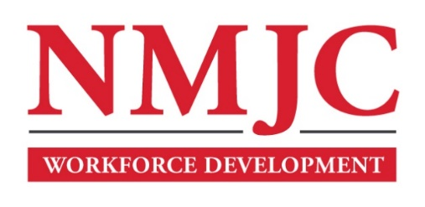
Clinical Medical Assistant Program – NMJC – Training & Outreach
Tuition - $2,600; Total Hours – 140 classroom + 160 hours clinical time
Location: 5317 N. Lovington Hwy, Hobbs, NM 88240
Monday January 22 6:00pm - 9:30pm
Wednesday January 24 6:00pm - 9:30pm

Monday January 29 6:00pm - 9:30pm
Wednesday January 31 6:00pm - 9:30pm
Saturday February 3 9:00am - 4:30pm

Monday February 5 6:00pm - 9:30pm
Wednesday February 7 6:00pm - 9:30pm

Monday February 12 6:00pm - 9:30pm
Wednesday February 14 6:00pm - 9:30pm

NO CLASS February 19 NO CLASS
Wednesday February 21 6:00pm - 9:30pm
Saturday February 24 9:00am - 4:30pm

Monday February 26 6:00pm - 9:30pm
Wednesday February 28 6:00pm - 9:30pm
Saturday March 2 9:00am - 4:30pm

Monday March 4 6:00pm - 9:30pm
Wednesday March 6 6:00pm - 9:30pm

Monday March 11 6:00pm - 9:30pm
Wednesday March 13 6:00pm - 9:30pm
Saturday March 16 9:00am - 4:30pm

NO CLASS March 18-22 NO CLASS

Monday March 25 6:00pm - 9:30pm
Wednesday March 27 6:00pm - 9:30pm

Monday April 1 6:00pm - 9:30pm
Wednesday April 3 6:00pm - 9:30pm

Monday April 8 6:00pm - 9:30pm
Wednesday April 10 6:00pm - 9:30pm
Saturday April 13 9:00am - 4:30pm

Monday April 15 6:00pm - 9:30pm
Wednesday April 17 6:00pm - 9:30pm

Monday April 22 6:00pm - 9:30pm
Wednesday April 24 6:00pm - 9:30pm
Saturday April 27 9:00am - 4:30pm

Monday April 29 6:00pm - 9:30pm
Wednesday May 1 6:00pm - 9:30pm

Monday May 6 6:00pm - 9:30pm

