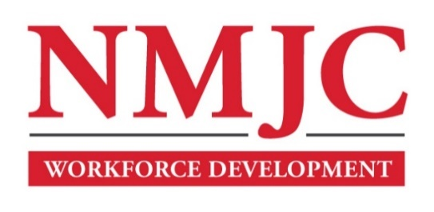
Clinical Medical Assistant Program – NMJC – Training & Outreach
Tuition - $3,000; Total Hours – 140 classroom + 160 hours clinical time
Location: 5317 N. Lovington Hwy, Hobbs, NM 88240
Monday August 17 6:00pm - 9:30pm
Wednesday August 19 6:00pm - 9:30pm

Monday August 24 6:00pm - 9:30pm
Wednesday August 26 6:00pm - 9:30pm
Saturday August 29 9:00am - 4:30pm

Monday August 31 6:00pm - 9:30pm
Wednesday September 2 6:00pm - 9:30pm

NO CLASS September 7 NO CLASS
Wednesday September 9 6:00pm - 9:30pm
Saturday September 12 9:00am - 4:30pm

Monday September 14 6:00pm - 9:30pm
Wednesday September 16 6:00pm - 9:30pm

Monday September 21 6:00pm - 9:30pm
Wednesday September 23 6:00pm - 9:30pm
Saturday September 26 9:00am - 4:30pm

Monday September 28 6:00pm - 9:30pm
Wednesday September 30 6:00pm - 9:30pm
Saturday October 3 9:00am - 4:30pm

Monday October 5 6:00pm - 9:30pm
Wednesday October 7 6:00pm - 9:30pm

Monday October 12 6:00pm - 9:30pm
Wednesday October 14 6:00pm - 9:30pm
Saturday October 17 9:00am - 4:30pm

Monday October 19 6:00pm - 9:30pm
Wednesday October 21 6:00pm - 9:30pm
Saturday October 24 9:00am - 4:30pm

Monday October 26 6:00pm - 9:30pm
Wednesday October 28 6:00pm - 9:30pm

Monday November 2 6:00pm - 9:30pm
Wednesday November 4 6:00pm - 9:30pm
Saturday November 7 9:00am - 4:30pm

Monday November 9 6:00pm - 9:30pm
Wednesday November 11 6:00pm - 9:30pm

Monday November 16 6:00pm - 9:30pm

