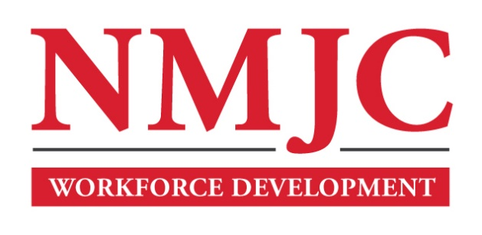
Dental Assisting Program – NMJC – Workforce Development
Tuition - $1,500; Total Hours – 60
Location 5317 N. Lovington Hwy, Hobbs, NM 88240

Monday July 27 6:00pm - 9:30pm
Wednesday July 29 6:00pm - 9:30pm

Monday August 3 6:00pm - 9:30pm
Wednesday August 5 6:00pm - 9:30pm

Monday August 10 6:00pm - 9:30pm
Wednesday August 12 6:00pm - 9:30pm

Monday August 17 6:00pm - 9:30pm
Wednesday August 19 6:00pm - 9:30pm

Monday August 24 6:00pm - 9:30pm
Wednesday August 26 6:00pm - 9:30pm

Monday August 31 6:00pm - 9:30pm
Wednesday September 2 6:00pm - 9:30pm

NO CLASS September 7 NO CLASS
Wednesday September 9 6:00pm - 9:30pm

Monday September 14 6:00pm - 9:30pm
Wednesday September 16 6:00pm - 9:30pm

Monday September 21 6:00pm - 9:30pm
Wednesday September 23 6:00pm - 9:30pm

