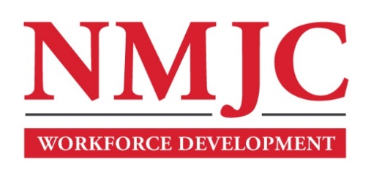
Clinical Medical Assistant Program – NMJC – Training & Outreach
Tuition - $3,000; Total Hours – 140 classroom + 160 hours clinical time
Location: 5317 N. Lovington Hwy, Hobbs, NM 88240
Monday January 12 6:00pm - 9:30pm
Wednesday January 14 6:00pm - 9:30pm

NO CLASS January 19 NO CLASS
Wednesday January 21 6:00pm - 9:30pm

Monday January 26 6:00pm - 9:30pm
Wednesday January 28 6:00pm - 9:30pm

Monday February 2 6:00pm - 9:30pm
Wednesday February 4 6:00pm - 9:30pm
Saturday February 7 9:00am - 4:30pm

Monday February 9 6:00pm - 9:30pm
Wednesday February 11 6:00pm - 9:30pm

NO CLASS February 16 NO CLASS
Wednesday February 18 6:00pm - 9:30pm

Monday February 23 6:00pm - 9:30pm
Wednesday February 25 6:00pm - 9:30pm
Saturday February 28 9:00am - 4:30pm

Monday March 2 6:00pm - 9:30pm
Wednesday March 4 6:00pm - 9:30pm
Saturday March 7 9:00am - 4:30pm

Monday March 9 6:00pm - 9:30pm
Wednesday March 11 6:00pm - 9:30pm

NO CLASS March 16-20 NO CLASS

Monday March 23 6:00pm - 9:30pm
Wednesday March 25 6:00pm - 9:30pm
Saturday March 28 9:00am - 4:30pm

Monday March 30 6:00pm - 9:30pm
Wednesday April 1 6:00pm - 9:30pm

Monday April 6 6:00pm - 9:30pm
Wednesday April 8 6:00pm - 9:30pm

Monday April 13 6:00pm - 9:30pm
Wednesday April 15 6:00pm - 9:30pm
Saturday April 18 9:00am - 4:30pm

Clinical Medical Assistant Program – NMJC – Training & Outreach
Tuition - $3,000; Total Hours – 140 classroom + 160 hours clinical time
Location: 5317 N. Lovington Hwy, Hobbs, NM 88240
Monday April 20 6:00pm - 9:30pm
Wednesday April 22 6:00pm - 9:30pm

Monday April 27 6:00pm - 9:30pm
Wednesday April 29 6:00pm - 9:30pm
Saturday May 2 9:00am - 4:30pm

