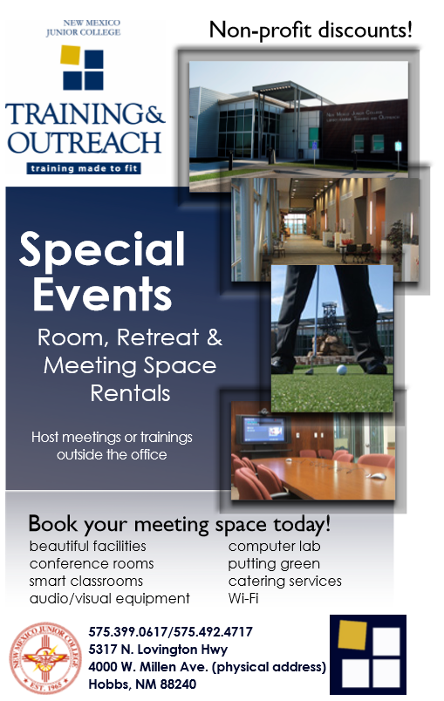
New Mexico Junior College
Book your meeting space today
Conference rooms, Smart Classrooms, Video conference.
(575)399-0617 sprebenda@nmjc.edu

