Athletic Assistants
Posting Date: 8/17/2018
Classification: Work-study
Description: 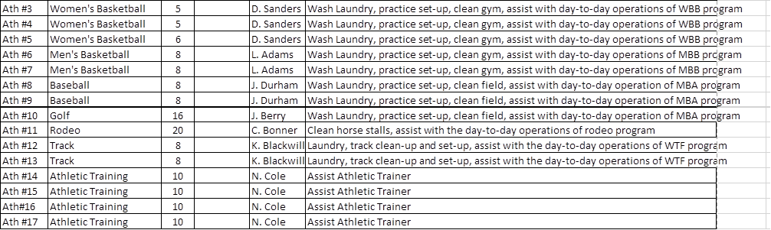
Qualifications: Student must have a Free Application for Federal Student Aid (FAFSA) completed and must be enrolled as a regular student. Student must meet satisfactory academic progress (SAP) requirements. Candidate should have excellent people skills and the ability to maintain a friendly attitude and work effectively with students, staff and faculty.
Pay Rate: $7.50 per hour.
Application Deadline: Open until filled
To Apply: To schedule an interview, please contact Michelle Jimenez 575-492-2740.
Application Deadline: Open until filled

